In conjunction with my application for employment at Buffalo State College, hereafter “employer”, I hereby authorize the employer and consent to the preparation by Sterling Infosystems, Inc. to conduct a pre-employment background investigation pursuant to the Fair Credit Reporting Act (FCRA) and New York law which may include, but is not limited to, a social security number verification, criminal records and history, educational and employment history verifications. The employer does not solicit personal credit or medical information.

I am aware that I have the right under the FCRA to request and receive information on any report received by the employer in conjunction with my application for employment. I authorize and request all courts and law enforcement agencies, educational institutions, and employers to release information without restriction or qualification to Sterling Infosystems, Inc. to provide to the employer.

I hereby release the employer, their respective officers, employees and agents from any liability and responsibility arising from preparation of the above described background check, investigation or report, and any resulting outcome or consequences. Employer will treat any information received as a result of this authorization as confidential, and it will only be made available to personnel with a legitimate need to know.

By my signature below, I certify the information I provided on this form is true and correct. I agree that this Authorization Release Form in original, faxed, photocopied or electronic (including electronically signed) form will be valid for any reports that may be requested by or on behalf of Buffalo State.

|  |  |  |  |  |  |  |  |  |
| --- | --- | --- | --- | --- | --- | --- | --- | --- |
| Title of Position to which you are applying: | | | | |  | | | |
| Department: | | | |  | | | | |
| Legal Name (last, first, middle initial): | | | |  | | | | |
| Maiden Name (if applicable): | | | |  | | | | |
| Current Address: (street) | | | |  | | | | |
| (city, state, zip) | | | |  | | | | |
| E-mail Address (required):** | | |  | | | | | |
| Home or Cell Phone: | | |  | | | | | |
| Social Security Number*: | | |  | | | | | |
| Date of Birth *(for ID purposes only)*\*: | | | |  | | | | |
| Previous Address (if moved within the last year): | | | | | |  | | |
|  |  | | | | | | | |
| Signature: | |  | | | | | Date: |  |

Note: Submitting an incomplete or illegible form may delay the background check results and the official appointment date.

***Please return Page 1 to Human Resource Management, Cleveland Hall 403, in a confidential envelope.***  
If you have any questions, please contact Human Resource Management at 716-878-4822.

*Not used as a hiring factor. Used only for identification purposes in the background check process. If a verbal contingent offer of employment is extended, you will be contacted by Human Resource Management and receive an e-mail from our background investigation vendor, Sterling Infosystems, Inc. Please respond promptly to limit any delay in processing your application.

**Applicants may create a free e-mail account from Google, Yahoo, etc.

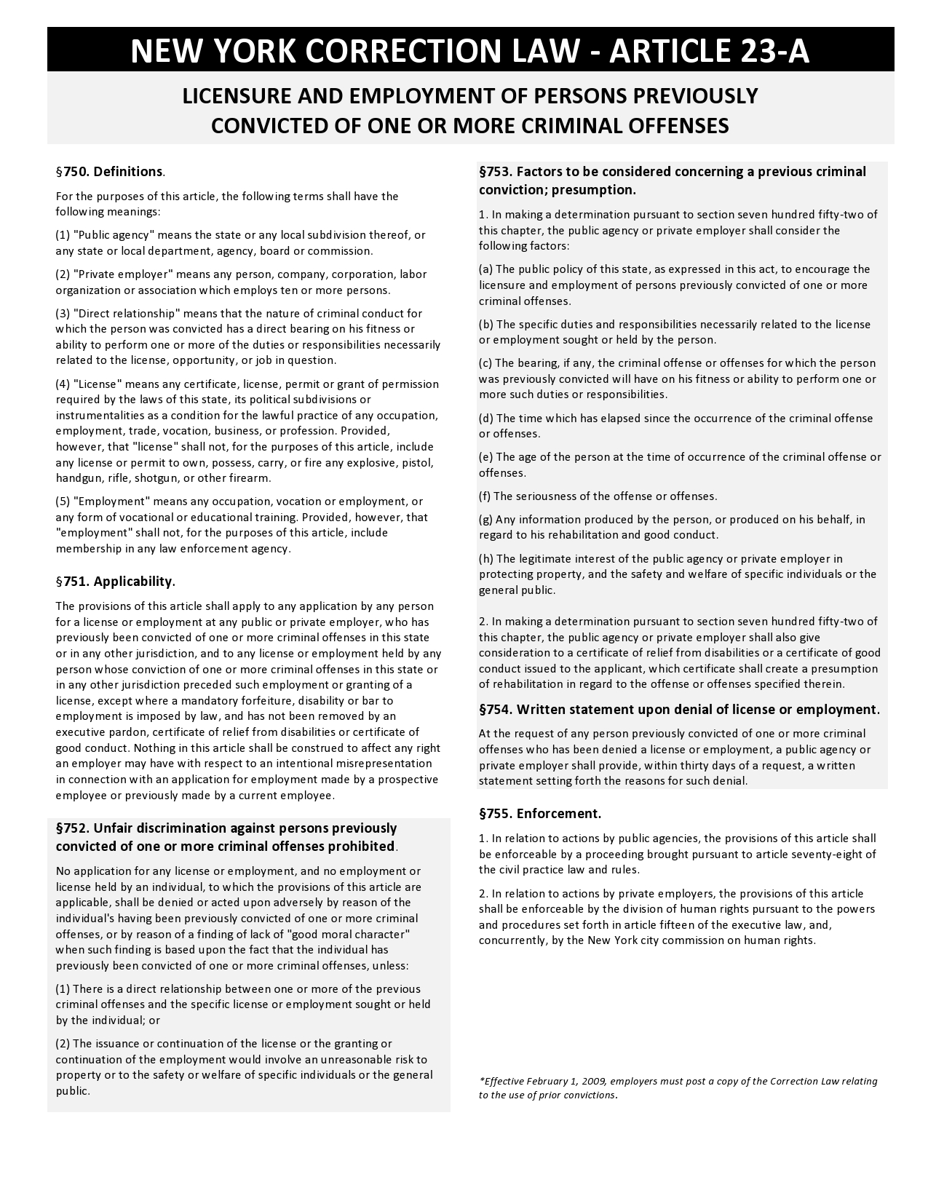

**State Law Notices Relating to Your Background Report**

New York residents and applicants only: Upon request, you will be informed whether or not a consumer report was requested, and if such report was requested, informed of the name and address of the consumer reporting agency that furnished the report. You have the right to inspect and receive a copy of any investigative consumer report requested by contacting the consumer reporting agency directly. By signing this acknowledgment and authorization for background investigation, you acknowledge receipt of Article 23-A of the New York Correction Law.

**A Summary of Your Rights Under the Fair Credit Reporting Act**

The federal Fair Credit Reporting Act (FCRA) promotes the accuracy, fairness, and privacy of information in the files of consumer reporting agencies. There are many types of consumer reporting agencies, including credit bureaus and specialty agencies (such as agencies that sell information about check writing histories, medical records, and rental history records). Here is a summary of your major rights under the FCRA.  **For more information, including information about additional rights, go to** [**www.consumerfinance.gov/learnmore**](http://www.ftc.gov/credit) **or write to: Consumer Financial Protection Bureau, 1700 G Street, N.W., Washington, D.C. 20552.**

* **You must be told if information in your file has been used against you.** Anyone who uses a credit report or another type of consumer report to deny your application for credit, insurance, or employment – or to take another adverse action against you – must tell you, and must give you the name, address, and phone number of the agency that provided the information.
* **You have the right to know what is in your file.** You may request and obtain all the information about you in the files of a consumer reporting agency (your “file disclosure”). You will be required to provide proper identification, which may include your Social Security number. In many cases, the disclosure will be free. You are entitled to a free file disclosure if:
  + - * a person has taken adverse action against you because of information in your credit report;
      * you are the victim of identify theft and place a fraud alert in your file;
      * your file contains inaccurate information as a result of fraud;
      * you are on public assistance;
      * you are unemployed but expect to apply for employment within 60 days.

In addition, by September 2005 all consumers will be entitled to one free disclosure every 12 months upon request from each nationwide credit bureau and from nationwide specialty consumer reporting agencies. See [www.consumerfinance.gov/learnmore](http://www.ftc.gov/credit) for additional information.

* **You have the right to ask for a credit score.** Credit scores are numerical summaries of your credit-worthiness based on information from credit bureaus. You may request a credit score from consumer reporting agencies that create scores or distribute scores used in residential real property loans, but you will have to pay for it. In some mortgage transactions, you will receive credit score information for free from the mortgage lender.
* **You have the right to dispute incomplete or inaccurate information.**  If you identify information in your file that is incomplete or inaccurate, and report it to the consumer reporting agency, the agency must investigate unless your dispute is frivolous. See [www.consumerfinance.gov/learnmore](http://www.ftc.gov/credit) for an explanation of dispute procedures.
* **Consumer reporting agencies must correct or delete inaccurate, incomplete, or unverifiable information.** Inaccurate, incomplete or unverifiable information must be removed or corrected, usually within 30 days. However, a consumer reporting agency may continue to report information it has verified as accurate.
* **Consumer reporting agencies may not report outdated negative information.**  In most cases, a consumer reporting agency may not report negative information that is more than seven years old, or bankruptcies that are more than 10 years old.
* **Access to your file is limited.**  A consumer reporting agency may provide information about you only to people with a valid need -- usually to consider an application with a creditor, insurer, employer, landlord, or other business. The FCRA specifies those with a valid need for access.
* **You must give your consent for reports to be provided to employers.** A consumer reporting agency may not give out information about you to your employer, or a potential employer, without your written consent given to the employer. Written consent generally is not required in the trucking industry. For more information, go to [www.consumerfinance.gov/learnmore](http://www.ftc.gov/credit).
* **You may limit “prescreened” offers of credit and insurance you get based on information in your credit report.** Unsolicited “prescreened” offers for credit and insurance must include a toll-free phone number you can call if you choose to remove your name and address from the lists these offers are based on. You may opt-out with the nationwide credit bureaus at 1-888-5-OPTOUT (1-888-567-8688).
* **Consumers have the right to obtain a security freeze**You have a right to place a “security freeze” on your credit report, which will prohibit a consumer reporting agency from releasing information in your credit report without your express authorization. The security freeze is designed to prevent credit, loans, and services from being approved in your name without your consent. However, you should be aware that using a security freeze to take control over who gets access to the personal and financial information in your credit report may delay, interfere with, or prohibit the timely approval of any subsequent request or application you make regarding a new loan, credit, mortgage, or any other account involving the extension of credit. As an alternative to a security freeze, you have the right to place an initial or extended fraud alert on your credit file at no cost. An initial fraud alert is a 1-year alert that is placed on a consumer’s credit file. Upon seeing a fraud alert display on a consumer’s credit file, a business is required to take steps to verify the consumer’s identity before extending new credit. If you are a victim of identity theft, you are entitled to an extended fraud alert, which is a fraud alert lasting 7 years. A security freeze does not apply to a person or entity, or its affiliates, or collection agencies acting on behalf of the person or entity, with which you have an existing account that requests information in your credit report for the purposes of reviewing or collecting the account. Reviewing the account includes activities related to account maintenance, monitoring, credit line increases, and account upgrades and enhancements.
* **You may seek damages from violators.** If a consumer reporting agency, or, in some cases, a user of consumer reports or a furnisher of information to a consumer reporting agency violates the FCRA, you may be able to sue in state or federal court.
* **Identity theft victims and active duty military personnel have additional rights.** For more information, visit [www.consumerfinance.gov/learnmore](http://www.ftc.gov/credit).

**States may enforce the FCRA, and many states have their own consumer reporting laws. In some cases, you may have more**

**rights under state law. For more information, contact your state or local consumer protection agency or your state Attorney General. Federal enforcers are:**

|  |  |
| --- | --- |
| **TYPE OF BUSINESS:** | **CONTACT:** |
| Banks, savings associations, and credit unions with total assets of over $10 billon and their affiliates | Consumer Financial Protection Bureau  1700 G Street N.W.  Washington, DC 20552 |
| Such affiliates that are not banks, savings associations, or credit unions also should list in addition to the CFPB | Federal Trade Commission  Consumer Response Center  600 Pennsylvania Avenue N.W.  Washington, DC 20580, 877-382-4357 |
| To the extent not included in the above, national banks, federal savings associations, and federal branches and federal agencies of foreign banks | Office of the Comptroller of the Currency  Customer Assistance Group  1301 McKinney Street, Suite 3450  Washington, DC 20219 800-613-6743 |
| State member banks, branches and agencies of foreign banks (other than federal branches, federal agencies, and insured state branches of foreign banks), commercial lending companies owned or controlled by foreign banks, and organizations operating under section 25 or 25A of the Federal Reserve Act | Federal Reserve Consumer Help Center  PO Box 1200  Minneapolis, MN 55480 |
| Nonmember insured banks, insured state branches of foreign banks, and insured state savings associations | FDIC Consumer Response Center  1100 Walnut Street, Box #11  Kansas City, MO 64106 |
| Federal credit unions | National Credit Union Administration  Office of Consumer Financial Protection (OCFP)  Division of Consumer Compliance Policy and Outreach  1775 Duke Street  Alexandria, VA 22314 |
| Air carriers | Asst General Counsel for Aviation Enforcement and Proceedings  Aviation Consumer Protection Division Department of Transportation, 1200 New Jersey Avenue, S.E.  Washington, DC 20590 |